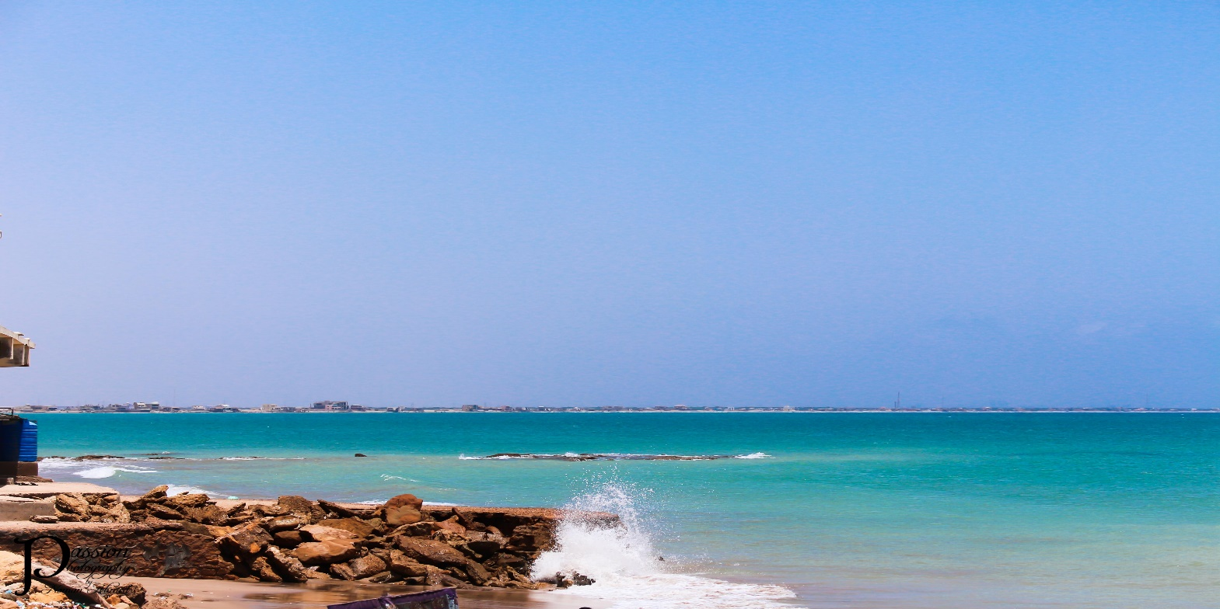

**HAWKS BAY BEACH**

**Welcome to Hawke’s Bay Beach**

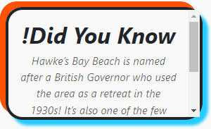Hawke’s Bay Beach, located just a short drive from Karachi, is a hidden gem along Pakistan’s coastline. Famous for its crystal-clear waters, golden sands, and serene environment, this beach offers the perfect escape from the city’s hustle and bustle. Whether you’re seeking a relaxing day by the waves, thrilling water sports, or a memorable picnic with family and friends, Hawke’s Bay has something for everyone. Known for its vibrant marine life and breathtaking sunsets, it’s a must-visit destination for nature lovers and adventure seekers alike.

**A Paradise for Nature Enthusiasts**

Hawke’s Bay Beach is a hidden gem on Karachi's

coastline, offering more than just a typical beach

outing. It's a sanctuary for those who cherish

nature, where golden sands meet the crystal-clear waters of the Arabian Sea. The beach is a haven for marine life, with endangered green turtles frequently visiting the shores for nesting. Watching these gentle creatures in their natural habitat is a magical experience that makes Hawke’s Bay stand out among other beaches. Whether it’s the mesmerizing sunsets or the rhythmic sound of the waves, the serene environment at Hawke’s Bay Beach provides a perfect escape for anyone seeking to reconnect with the natural world.

**Thrills and Adventure at Every Turn**

Hawke’s Bay Beach is not just about relaxation; it's also a hotspot for adventure and excitement. The beach offers a variety of activities for thrill-seekers, from jet skiing and speed boating to camel rides and horse riding along the shore. The calm yet playful waters make it ideal for swimming and snorkeling, while the wide sandy stretches are perfect for games like volleyball or building elaborate sandcastles with family and friends. For those looking to explore, nearby rocky outcrops and caves present opportunities for discovery and exploration. Whether you're craving adrenaline-pumping water sports or simply wish to unwind under the sun, Hawke’s Bay promises a memorable experience for everyone.

**Nearby Attractions to Explore Around Hawke’s Bay Beach**

Hawke’s Bay Beach is not just a standalone destination; it serves as a gateway to some of the most captivating attractions in the region. Here’s a glimpse of what’s nearby:

* Sandspit Beach

Located just a few kilometers away, Sandspit Beach is a must-visit for nature lovers. Known for its tranquil environment and shallow waters, it is also a famous nesting ground for green and olive ridley turtles. Visitors can enjoy a serene day by the sea or take a relaxing camel ride along its golden sands.

* Paradise Point

A short drive from Hawke’s Bay, Paradise Point is a breathtaking natural rock formation with an iconic arch carved by the sea waves. This picturesque spot is perfect for photography, picnics, and enjoying the panoramic views of the Arabian Sea.

* Manora Island

Take a boat ride from nearby Keamari to reach Manora Island, a fascinating destination steeped in history. The island is home to the historic Manora Lighthouse, old colonial buildings, and serene beaches that offer a blend of adventure and history.

* Cape Mount Beach

For those seeking a more secluded and pristine beach experience, Cape Mount Beach is an excellent option. Its untouched beauty, combined with its clear waters and tranquil surroundings, makes it an ideal escape for peace seekers.

* Karachi Fish Harbor

Located close to Keamari, the Karachi Fish Harbor provides a glimpse into the bustling local fishing industry. Visitors can watch fishermen bring in their daily catch and even sample some of the freshest seafood available in the city.  
Whether you're interested in scenic beauty, marine life, or cultural history, the attractions around Hawke’s Bay Beach ensure your trip is filled with unforgettable moments.

***RIDING***

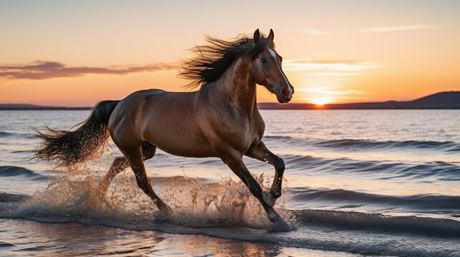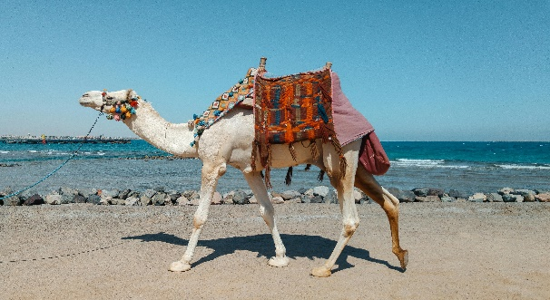

***! Camel riding at HAWKSBAY BEACH is a fun and iconic activity for visitors. Decorated camels offer safe rides guided by skilled handlers.***

***! Beach bike riding at HAWKSBAY BEACH offers a thrilling experience, with rental bikes designed for smooth rides on the sandy shoreline.***

***! Horse riding at HAWKSBAY BEACH is another thrilling activity for visitors. Beautifully adorned horses are available for guided rides along the shoreline.***

**Unveiling the Beauty of Hawksbay Beach: Karachi’s**

Hawksbay Beach is a breathtaking coastal gem nestled along Karachi's Arabian Sea shoreline, known for its crystal-clear waters, golden sands, and unspoiled natural beauty. This idyllic retreat offers an unmatched escape from the city’s hustle and bustle, drawing visitors from near and far to experience its tranquility. The rhythmic sound of waves, combined with the cool sea breeze, creates an ambiance of calmness that refreshes the soul. Whether you’re looking to unwind, enjoy a family picnic, or simply take a stroll along the shoreline, Hawksbay Beach delivers an unforgettable experience.

**Hawksbay Beach: A Perfect Blend of Nature, Adventure**

Famed as one of Karachi's most beloved beaches, Hawksbay Beach is not only a visual delight but also a hub of recreational activities and natural wonders. It’s a hotspot for families, adventure enthusiasts, and marine-life admirers. Known for its turtle nesting grounds, Hawksbay offers a rare opportunity to witness endangered green and olive ridley turtles during their nesting season. Adventure seekers can enjoy thrilling activities such as jet skiing, camel rides, and beachside BBQs, while nature lovers can soak in the untouched beauty of this coastal paradise. Whether it's the sunrise painting the sky in hues of orange and pink or the serene moments under the starlit sky, Hawksbay Beach is a true haven for all.

**LOCATION**

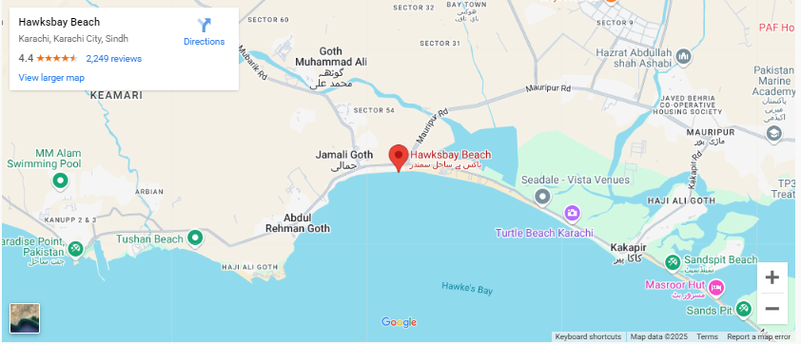

**Hawks Bay Beach is located about 20-25 km west of Karachi, along the Arabian Sea coastline. It’s a popular spot for picnics and swimming.**

**Why Visit Hawksbay Beach?**

**Hawksbay Beach is a serene escape from Karachi’s busy city life, offering golden sands, clear waters, and exciting activities like jet skiing and camel rides. It’s also a haven for nature lovers, being home to endangered turtle species. Whether you seek relaxation or adventure, Hawksbay promises unforgettable memories.**

**FEATURED PRODUCT**









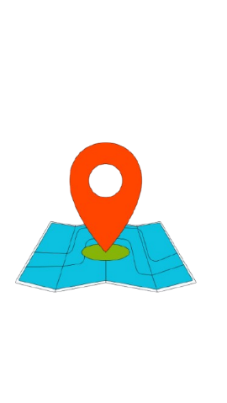**SHOP LOCATION**

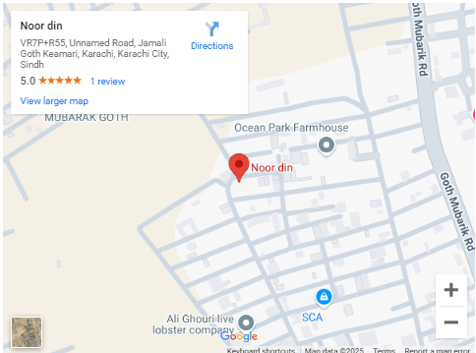

Noor Din is a locality in Karachi, located in the Korangi area, which is in the southeastern part of the city.